**Real world Cases:**

**Imbalanced data**: there is no problem of imbalanced data in linear regression as there are no class labels.

**Feature Importance & Interpretability:** If features are not multicollinear then we can use wj associated with feature j in case of L1 regularization to obtain important feature.

Why L1 reg: because it will make w = 0 for irrelevant features.

**Feature Eng/Feature Transform:** Same as logistic reg.

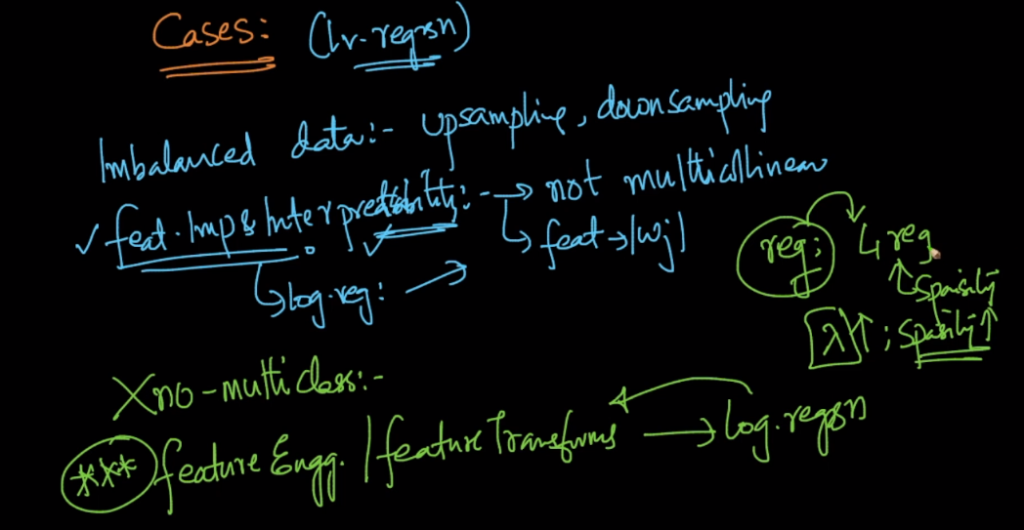

**Outliers:**

Outliers can make a huge impact to model, because of square loss, therefore it’s better to remove them.

**Technique to remove outlier:**

1. Train model using D-train.
2. Find points which are very far from obtained plane, using y-y^.
3. Remove these points
4. Prepare a new dataset as D-train’ = D-train – Outliers.
5. Train model using new dataset D-train’
6. Repeat all 4 steps until you get appropriated data.

This technique of removing outlier is called RANSAC.

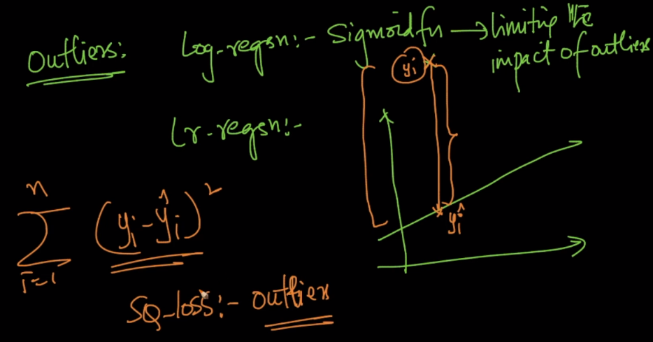

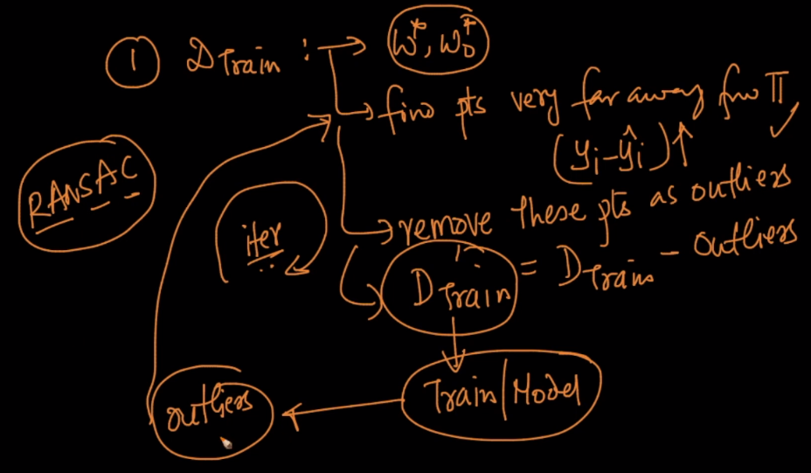

**Comments:**

1)

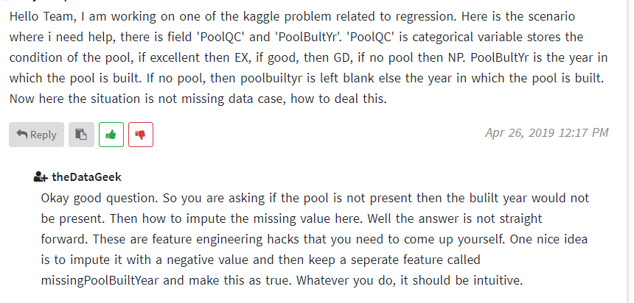

2)

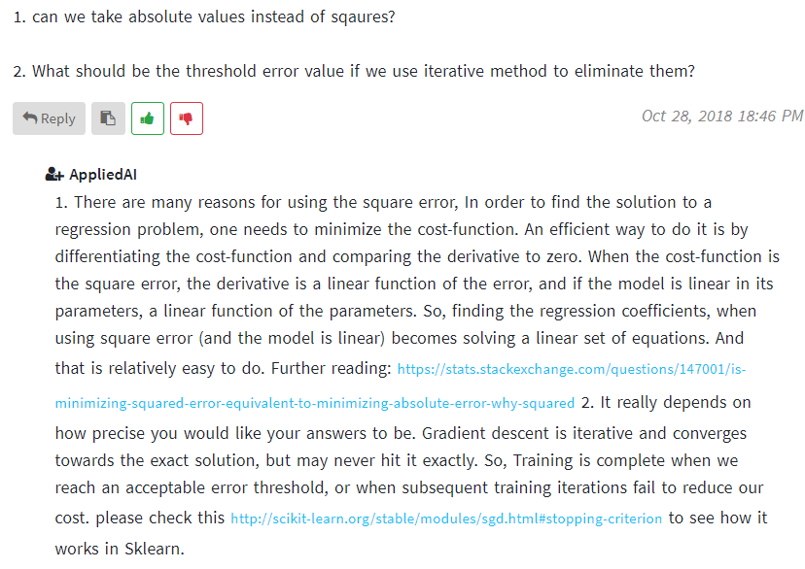

3)

